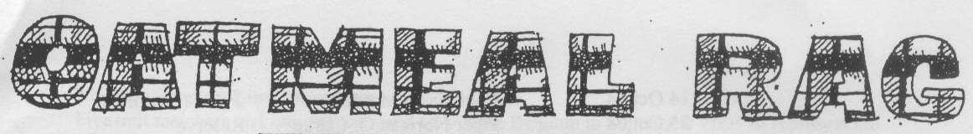
THE QUEEN’S OWN CAMERON HIGHLANDERS OF CANADA
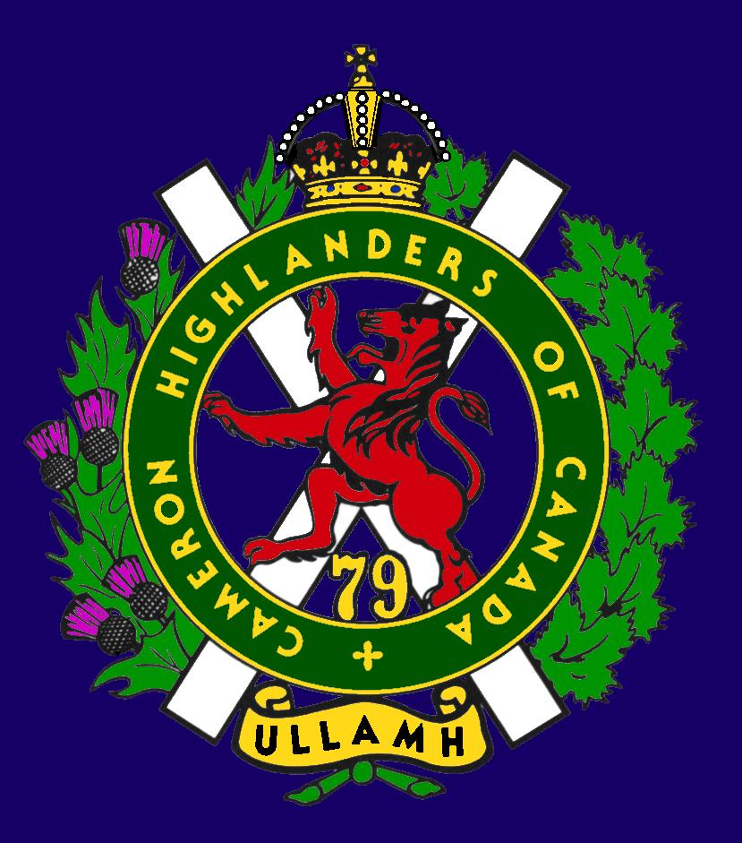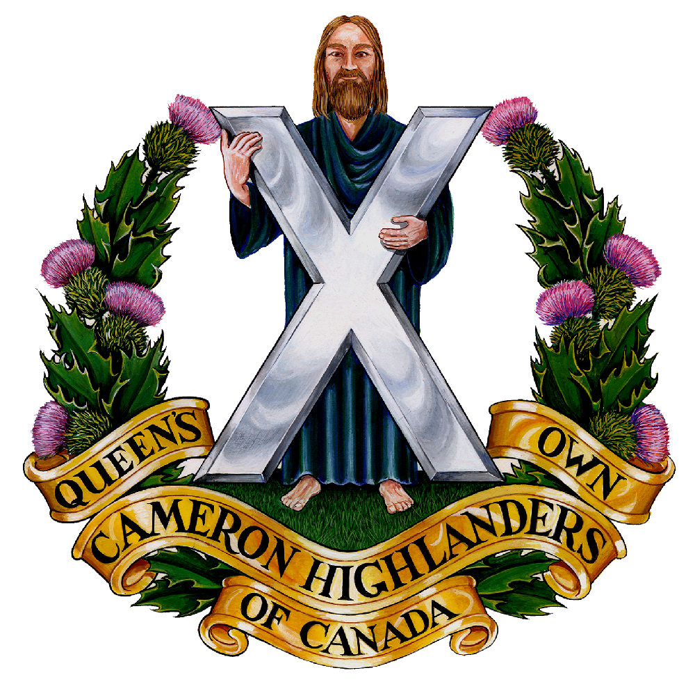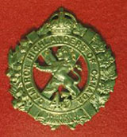
CAMERON ASSOCIATION IN CANADA
THE QUEEN’S OWN CAMERON HIGHLANDERS OF CANADA
MINTO ARMOURY, 969 ST. MATTHEWS AVE
WPG, MB R3G 0J7

2010/2011 OFFICERS

PRESIDENT | Taffy Gray | 198 Seekings St  Headingly, MB | R4J 1B1 | 889-5655
VICE-PRES | Steve MacMillan | 351 Ainslie St  Wpg, MB  sdmacmillan@shaw.ca | R3J 2Z7 | 831-0542
SECRETARY | Hugh O’Donnell | 713 Cambridge St  Wpg, MB  hodonnell@shaw.ca | R3M 3G2 | 285-7222
TREASURER | Dave Gibson | 104 William Gibson Bay  Wpg, MB  dwgibson@mts.net | R3C 5L7 | 222-9509

Executive Board

Past Pres | Bill Worden | 47 Flett Ave | R2K 3N3 | 669 -9888
 | Mike Nickerson
 | Mitch Prudhomme | 790 Parkhill St | R2Y 0V5 | 837-5778
 | Sean Rivas
 | Don Steenson | N/A | N/A
 | Karen Tyler | 255 Aldine St  Wpg, MB | R3J 2A9 | 414-0973
Foundation Trustees | Don Steenson  (2010 – 2012) | Marc Gautron  (2011-2013)
Auditor

* Last Post *
ALEC FRANK BLOODWORTH (published on August 06, 2011)
http://www.passagesmb.com/obituary_details.cfm?ObitID=181176

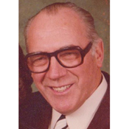

Alec Frank Bloodworth, on July 18, 2011, passed away peacefully at the age of 93, of natural causes. He will be lovingly remembered by his wife Ruth, by his sons, Glenn (Margaret), Keith (Stephanie), by his daughter Helen (Richard), by his grandchildren, and by his great-grandchild. He was predeceased by his parents, William and Catherine, by his brothers, Bill, Charlie, Bob and Arthur, by his sister, Marjorie, by his son Frank, and by his daughter Mary. Alec was born February 15, 1918, and grew up on a farm in the RM of Rockwood, and later, the family moved to Winnipeg. At 15, Alec joined the Queen's Own Cameron Highlanders' cadet corps, and at 18 joined the regiment. Alec met his wife Ruth at a dog show at the age of 19. They were married on December 26, 1939, and last year they celebrated their 71st wedding anniversary. He enlisted for active duty on September 2, 1939 with the Cameron's. He served with them overseas during World War II and It was overseas that he found his love for woodworking. Studying under a master carver, he spent much of his free time honing his craft. A service will be held to celebrate Alec's life on Sunday, August 14, 2011, at 11:00 a.m., at Minto Armouries, 969 St Mathews Ave. In lieu of flowers, if friends so desire, a donation may be made in his memory to Wounded Warriors through CanadaHelps.org

Private Irwin Eisler (Published April 26, 2011)
http://www.elliotlakefuneralchapel.com/view.php?id=181
Passed away at the St. Joseph’s General Hospital in Elliot Lake on Monday April 25, 2011 in his 92nd year. Beloved husband of Darlene Eisler of Elliot Lake. Loving father of Edward Eisler (Diane) of Caledonia and Harvey Eisler (Carolyn) of Sault Ste.Marie. Friends will be received at the Elliot Lake Funeral Chapel and Cremation Centre (36 Ontario Ave) on Friday April 29, 2011 from 10:00 a.m. until the time of service at 11:00 a.m. Interment to follow at Woodlands Cemetery in Elliot Lake. Memorial contributions to The War Amps would be appreciated by the family. Legion Branch: Elliot Lake Branch, Ontario. Unit: Queen's Own Cameron Highlanders of Canada; World War 2
http://www.legionmagazine.com/en/lastpost/details.asp?alpha=E&offset=950&LastPostData_ID=309521
Officer Cadet Patrick W. CLARKE (Published ?)
http://www.legionmagazine.com/en/lastpost/details.asp?tfm_order=DESC&tfm_orderby=DateDeceased&alpha=C&offset=14150&LastPostData_ID=309301
Date Deceased: 23 March 2011 Age: 77 yrs Service Number: TH81417
Unit: Royal Canadian Dental Corps, Queen's Own Cameron Highlanders of Canada
Legion Branch: Charleswood Branch, Winnipeg, Manitoba
* Sick & Visiting *
Ed Abraham (39/45) – Nothing heard for over a year now and no replies to emails have arrived I’m sorry to say.

Bill Douglas (39/45, Post WW2 Cameron) – Bill has had a hospital stay for treatment. His replacement ticker was giving him grief so he’s helping the Staff at St. B. learn how to treat a Dieppe veteran properly. They are quick learners he reports – but the food is a bit cool (even the tea !) when it gets to him. He still prefers St. B. to the Stalag stay after Dieppe but is hoping that things get worked out sooner than later so that he can enjoy Christmas with his family in settings with warm food.

Doug Ludlow (Post WW2 Cameron) Is still in the St Norbert Personal Care Home at 50 St Pierre St. Any and all visitors are advised strongly to call ahead before visiting.
The number to call is 269 – 4538.
http://members.winnipegdirect.info/p/st-norbert-personal-winnipeg-50-st-pierre/
Lloyd McDougall (39/45) 19 Sept 2010 I got by for a visit with Lloyd. He’s still as feisty as any of the guys that beat Hitler’s SS and Paratroopers and enjoys a visit.
Ocdt Tanya Bowen (formerly a clerk with 38 CBG) still does us the very great service of dropping in to Deer Lodge to visit with Lloyd and bring him the latest Oatmeal Rag.
For those who can drop by he’s Lloyd McDougall and he’s in Tower 5 or
T5 – 531, DEER LODGE CENTER, 2109 PORTAGE AVE.

Roy Taylor (WW2 RAF, Post WW2 Cameron) Roy is at home and comfortable. He enjoys short visits but does get tired quickly.

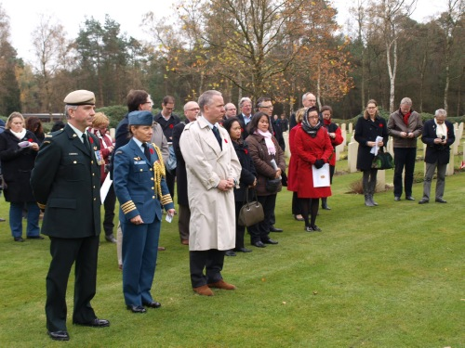

November 11-2011 Mr. G.J.van't Holt Chairman Welcome Again Veterans Foundation and member of Information Centre Foundation, hosted Canada Ambassador to The Netherlands H.E. Peter Lambert
and his Embassy Staff visit to the new Information Centre Holten Cemetery and a private Remembrance Service. There are at least 15 of our 1939-45 Camerons buried at Holten.

* President's Message *
Taffy wrote a lengthy report covering both events and thank you’s for the last year> here are the highlights:
- In Taffy’s opinion the WITG Men’s Dinner 2010 was not well done with regard to our Regimental traditions and was very off the cuff. Maybe we can coord this affair better for 2011’s dinner ? We of the Association Executive would be happy to help out with planning and such aspects as we are asked to help with.
- Cameron Pipes & Drums – The new P/M, Ian Ferguson, is a blessing and a keeper !
- Regimental Kit shop points – We need to get this squared away and find out what people want. Suggestions anyone ?
- 2010 Robbie Burn’s Dinner – A Big “Job Well Done” to all who ran it !
- Kirk Parade – Taffy feels that we should try to get a better Assn turnout numbers wise for 05 Feb 2012. Even if it’s cold out it’s only once a year guys !
- Cameron cadets – Can we help them out in any way ? Are they even interested in our help/support ?
- “Well Done !” to Cpl John HB for the excellent Scotch Tasting event;
- Reunion Golf – This year ran very slowly and some people got cold food. We’re working on that so it won’t happen again. Regarding the current “Veteran’s Trophy”, maybe we could ask Vi Miller (or family) to present the Veteran’s Trophy next year ? We’ve also discussed renaming it “The Russ Miller Veteran’s Trophy”. Any thoughts about that idea are welcome so please let us know. By the way, where are all the other Cameron event trophies and are they being maintained ? Are there any for the Cameron Highland Games out there from the old days ?
- 100th Plaques – “Well Done” to Hugh O’Donnell.
- Reunion 2011 – Job well done to all & keep it up. Next year PLEASE pay attention to the Pipes & Drums. They’re not busking on a corner for change you know, they’re playing for you - so pay them the courtesy of watching and killing the TV for a bit. We will need a designated person or team to run the lift next year. The number of our long-time members who need this help is not slowing down – thankfully !
- Sick, Visiting & Last Post – “Well Done” to Len Johnson and all who help him with it !
- Oatmeal Rag – “Well Done !” to the editors and their helpers.
- Thanks from Taffy to Regimental Museum, Advisory Board, & Foundation for their help & support over his term of office this year.
- Re the Cameron Museum – Sgt Tyler needs help with workload. Frederick Carsted suggested that maybe we do a 2015 200th anniversary of Waterloo display. Grant, anybody else interested ?
- Cameron web site is looking good.
- Is there anything we of the Cameron Assn can do for our troops or new veterans ?
- We need to start discussion re what is a veteran to us now ? More discussion needed re the Cameron Golf Veteran’s trophy on this subject at the next AGM.

* Vice-President's Message *
The Association Mess Dinner concept still taking shape. It’s looking like a Ladies Dining In type event. More to follow soon.

* Reconnect with Former Camerons *

This is an important thing to do for the health of the Association. There are still lots of former Camerons out there that we don’t know about for various reasons. Just because you or they weren’t WW 2 or Korea veterans doesn’t make them any less important to the Cameron Association. Please help us locate them and bring them back into the fold. The ranks of the WW 2 guys are terribly thin now and the torch must pass to the following generations of Camerons that we may continue to serve our fellow Camerons.

Mark Pearson wrote on the Wall for The Annual Cameron Reunion. (Facebook Event)
Thursday, August 18, 2011 6:50 PM
Mark wrote:
"Sorry guys, it would have been nice to see everyone together again, and play golf as well. Currently though I am teaching a course in Edmonton, which leaves me out of luck. Have a good bash! ULLAMH!"

David McCracken wrote:
Date: Tue, 23 Aug 2011 11:00:26 -0400
Subject: Cameron Association Annual
Hi guys,
I hope the event went well. My world is nuts. We are coming to the end of a major proposal that is the culmination of 10 months of intensive engineering and a preceding year of lighter effort. Then I must catch up on sleep and paperwork. Allison and the kids are all well. They are off in Toronto and other places for a summer holiday. I hope all is well in your world,
David
* Dues Payable Now *
Please send your payment to our membership/treasurer Dave Gibson ASAP. If you are not sure of your status please contact Dave and he’ll either be happy to take your payment or be most unhappy that he doesn’t get to take any more money from you this year.
* Association Activities *

Mr. Len Johnson from the Assn represented us at the May 15th Royal Canadian Legion Zone parade. He laid a wreath for our Fallen Comrades as part of the ceremony. Len also represented the Assn at the June 12th Lac du Bonnet Parade and placed a wreath there too.

* Cameron Association Constitution Amendment *

At the 26 Sept 2011 AGM we amended our 15 Jan 2011 Constitution by creating a new membership category paragraph which reads:
The Association may admit to Associate Membership in the Association any person of good character who is not eligible as a Regular Member as herein provided but who is in sympathy with the aim and objects of The Association and who would assist in the advancement of same. The Associate Membership category is non-voting and Associate Members cannot hold office, but are encouraged to support Association functions. Its intent is to allow families of past or current serving members of the Regiment and former Cameron Cadets of adult age to become members of The Association. The annual subscription fee will be the same that of Regular and Honorary membership categories with discretion allowed for special cases by the Association Executive.
The new membership category has been created and we have renumbered the existing paragraphs starting with Paragraph 6 and onwards sequentially.
Hugh O’Donnell
Secretary
Cameron Association in Canada

* Unit Web Site *
The Unit web site is still up running at:
http://thequeensowncameronhighlandersofcanada.net/
Our Picasaweb site is also worth a look and is full of little details about our history:
http://picasaweb.google.com/117042978234752447737?gsessionid=2I4fhFnicaBQw1UpIRMSlw

* Regimental Events *

Reinforcements:

Sgt to WO Matt Lumsden. Matt is our first “Home Grown” WO since WO Mike Mutch was promoted to that august rank a long time ago now. Great work Matt and thanks for sticking it out with us !!!

Born to Sgt Dave and Lisa Gibson: William Gibson on 28 Oct 2011.
Congrats to you all !

* Regimental Events *

Rounds Completed:
Annual Reunion Weekend: 19 - 20 August 2011
This year we ran the event in the Minto JR’s Mess. It had a few things going for it which the previous venues (Minto Officer’s Mess, WO’s & Sgt’s Mess) lacked – cold beer on tap, a north facing exposure (which meant that it wasn’t a bake oven right from the get go), and lots of comfy chairs for our long time members like Donny Morrison, Roy Taylor, Bill Douglas, Bill Duncan, Dick Worden, Max Katz, Vic Peterson, and Ken Smith to relax in. Let us know if you think you’d like to see it there again.
It was particularly great to see John MacMillan, Chris Roos, Andy DeBruin, Don Malak, Henri Marcoux and several others there that we haven’t seen around the Unit Lines or Mess in quite some time.
We sold a number of memberships during the 100th to former Camerons whom we hoped would stay current. We have sold 65 memberships so far this year. 17 were “new” (did not join last year so got a pin). We also had 3 memberships pre-paid from previous years.
Of the 94 members we had last year; 3 were pre-renewed, 48 renewed on Dieppe night, 10 others are local and we hope to catch them on the 06th of Sept, and the other 33 weren’t there on the 19th mostly because they live outside Winnipeg but a few were from Winnipeg and the unit.
Special thanks are due a number of people. First to the CO, LtCol Brett Takeuchi, by whose kind permission we were allowed to have the Regimental Colours present for this event. Secondly, we owe thanks to Donald MacDonald and our Past President Bill Worden for running the Golf & BBQ. Thanks very much for helping to make the weekend what it was !

Incoming Rounds:
17 Dec 2011 – Men’s Christmas Dinner: Please contact a member of the Executive to let us know if you are interested in coming. They need to know the numbers very soon, so call ASAP !
05 Feb 2012 – Annual Kirk Parade to 1st Presbyterian. Let’s try for a really good turn out from those of us living in Wpg at least !

* Links *

A fitting tribute page:
http://www.theprovince.com/news/we-salute-our-heroes/index.html
Welcome Again Veterans web site for Holten, The Netherlands:
http://www.come.to/wavholten

* Historical Notes *
This arrived a little while ago. The author and webmaster, Mr. Steve Pady, has done a brilliant job of, as he puts it “digitizing” his late great uncle Morris’ service with the Camerons during the Second World War.
This site is well worth a look for anyone interested in such personal history sites. It is exceptional in that the places mentioned in the War Diary and major Cameron battle sites have been marked using Google Earth *.kmz mapping files. For those not familiar with Google Earth it basically will “fly” you over the terrain in question on current maps. You do get something of a feel for the terrain and high features even though it has obviously been some 67 odd years. He has marked some of the key features of the battlescape of those first Cameron battlefields after Dieppe. If you read the War Diary and follow the maps you will get a very clear picture of what was going on in those battles.
Hi Hugh,
I have been researching my great uncle, Morris Pady, who served with the Cameron Highlanders of Canada during WW2 up until Operation Totalize, where he was wounded and later died. I have put together a website that is a compilation of all of the material I have gathered. While some of the information is specific to him, a lot of it is regimental in nature. It's the least I can do for my great uncle. Hopefully also, by digitizing a lot of the stuff, we can keep this information from being lost to time and continue to pay tribute to our vets… here it is:
http://morrispady.shawwebspace.ca/
Thanks!
Steve Pady
Edmonton, AB

* More Links *

Libyan Rebels using Cdn microdrones (thanks to Sgt T. Seeley & Piper R Eunson):
http://www.forbes.com/sites/kashmirhill/2011/08/26/how-libyan-rebels-got-a-120000-mini-drone/
- Maybe we can make a deal somewhere to access this tech for “A” Coy EX’s ?

Afghanistan: July 2011
http://www.theatlantic.com/infocus/2011/08/afghanistan-july-2011/100118/

http://www.theatlantic.com/infocus/2011/08/afghanistan-august-2011/100139/
http://www.theatlantic.com/infocus/2011/10/afghanistan-september-2011/100161/
http://www.theatlantic.com/infocus/2011/11/afghanistan-october-2011/100182/
#27 Master Corporal Byron Greff’s Repat ceremony. RIP MCpl. Greff.

Vernon Army Cadet Camp pictures
http://www.armycadethistory.com/vernon_photo_gallery%201.htm

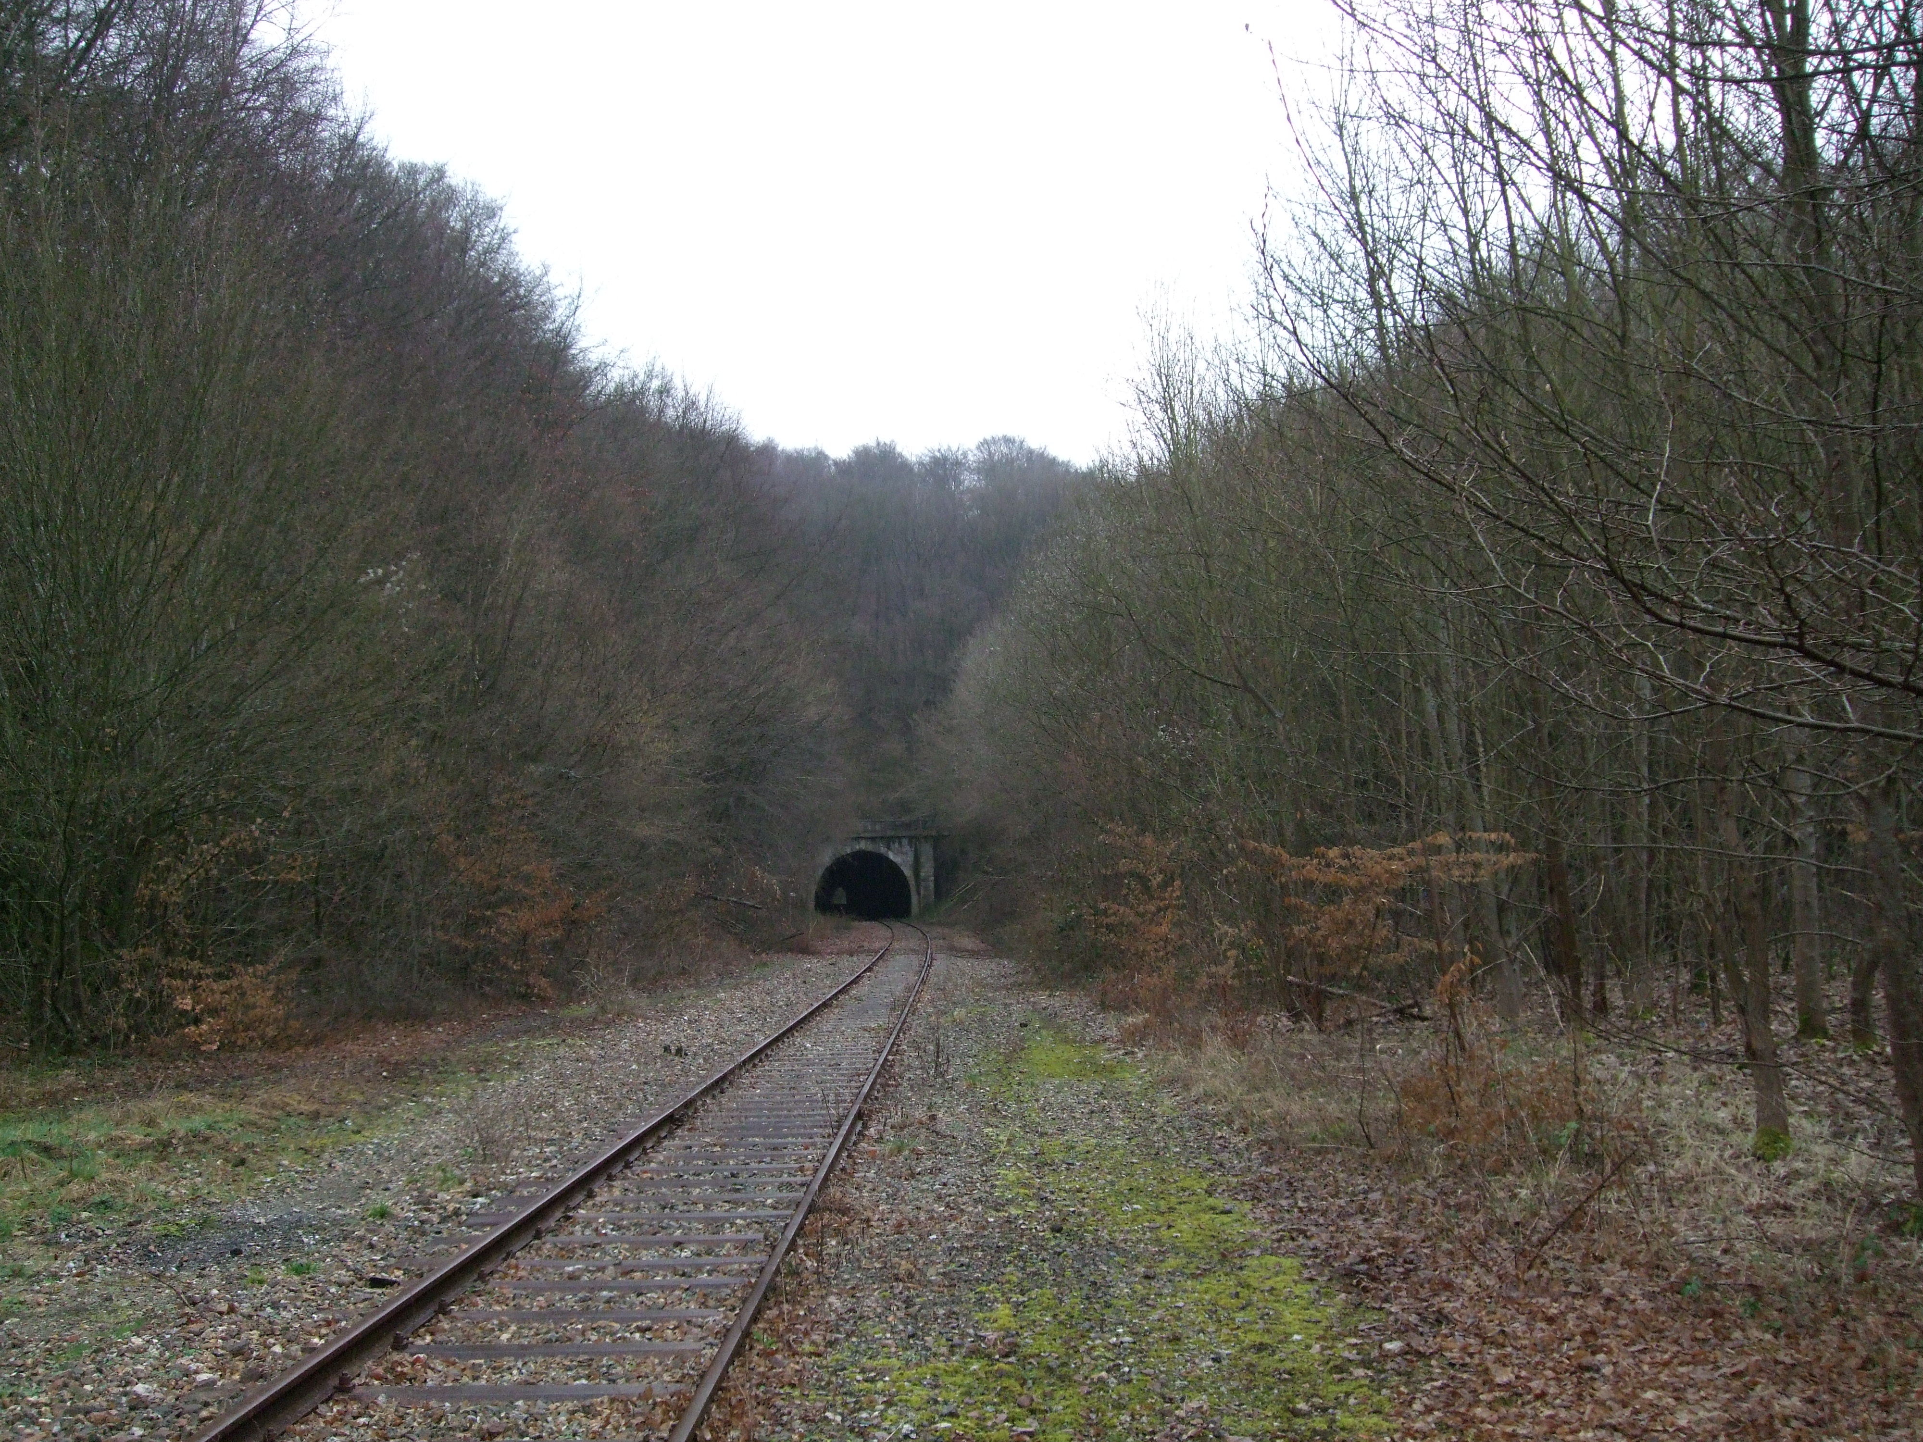
Forest de la Londe battlefield recent picture from Mathieu Guerin He lives in the area and is researching the battle. M. Guerin would like to hear from any of you who were there.

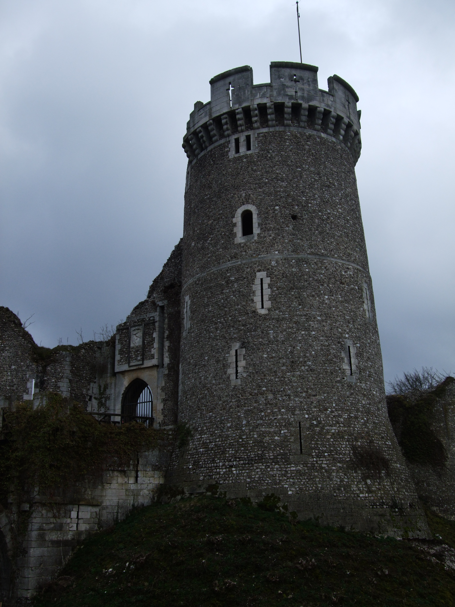
This is a recent picture from the Forest de la Londe battlefield. It is the castle of Robert the Devil. Our regiment knew this as a “monastery”. M. Guerin would like to hear from any of you who were there to help him put together a history of his area. He at least does not want you or your efforts to be forgotten.

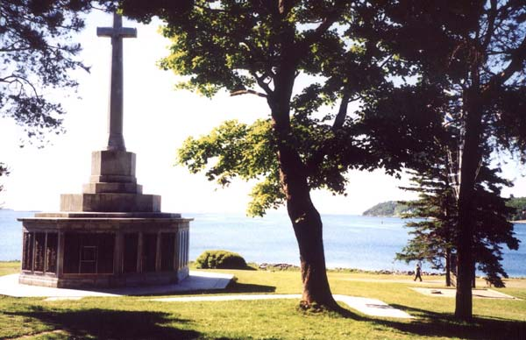
Cameron Soldier Listed on Halifax Memorial

Joan Russell, a professor at McGill University, emailed me in August concerning the wartime service of her uncle William Davidson. The family was interested in getting information as to his military affiliation and how he died.

Using the information Professor Russell gave me, I did a search on the internet and found that Cameron soldier William Alexander Davidson was one of 206 passengers and crew who were lost when troop ship SS Nerissa was torpedoed off the Irish coast on April 30, 1941. I learned also that Davidson was the only Cameron among the 290 passengers.

It appears that appendicitis had separated 19 year-old Pte Davidson from his Cameron comrades and prevented him from boarding an earlier crossing of the North Atlantic. Bad luck. The delay had placed him on the last voyage of the doomed SS Nerissa.

The names of those who did not survive the U boat attack are among the many more listed on the Halifax Memorial shown above. Dedicated on November 11, 1967, the Halifax Memorial stands in memory of the men and women of the Navy, Army, and Merchant Navy who lost their lives and have unknown graves. The story of SS Nerissa is well told at http://ssnerissa.com/

Requests for information similar to the above are routinely and expertly handled by Sgt Gant Tyler in his role as curator of the Cameron Museum. He receives a steady stream of queries from families wanting to learn more about a relative’s former service.

Art

KOREA VETERANS ASSOCIATION OF CANADA INC
http://www.kvacanada.com/last%20Hurrah.htm
The Last Hurrah was a final grand gathering for those who served in Korea between 1950 and 1956, Canada's third bloodiest conflict. Participants included those who served during the War 1950 to 1953 and during the Peacekeeping phase 1953 to 1956.
The Korea Veterans Association of Canada also hosted The KVA Heritage Unit, those who were Prisoners of War, and those who were injured in the B.C. Canoe River train accident in November 1950 (17 gunners killed) on their way to Korea. Invited guests also included those who served with Allied Nations and Korean-Canadians. Other guests also included Wives, Wives of Deceased Veterans, Caregivers, Children and Grandchildren of Veterans .

The Soldiers who Survive the Wars are The Veterans
Who Weep at the Sound of Pipes and
March To Keep The Faith for Brothers Lost
Who Did Not Die In Vain, it is Their Rite to Remember,
Soon they Will Pass The Torch as They Too will be no More
and Dare You Follow in their Footsteps and Never Forget.


From Robert Rushbrook of Project Maple Leaf CA / NL http://www.come.to/wavholten

I need a piper for a Cameron Association member’s funeral ? ? ?
For those of you who are trying to plan ahead or suddenly need to book a piper for one of our Comrades and don’t know how it is done here you go:
1. Contact the President of the Cameron Association or the Editor of the Oatmeal Rag at a reasonable hour; and
2. We’ll pass you the contact information of the current Cameron Pipe-Major (because the appointment does actually change from century to century or so and otherwise you may call the wrong guy); and
3. The P/M will help you to make the appropriate arrangements.

We are seeking sponsors or advertisers to help defray the cost of this publication. If anyone is interested or has any suggestions as to whom to contact please let us know and we'll be happy to do the follow up.
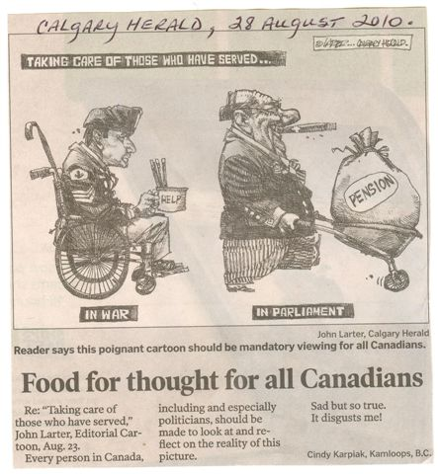

A veteran is someone who, at one point in his life, wrote a blank check made payable to 'CANADA ' for an amount "up to and including my life."
That is Honour, and there are way too many people in this country who no longer understand it.

“It wouldn’t be an Oatmeal Rag w/o a Wee Joke” (Russ Miller)
An Englishman, a Scotsman, an Irishman, a Latvian, a Turk, an Aussie, a German, an American, an Egyptian, a Japanese, a Mexican, a Russian, a Pole, a Lithuanian, a Swede, a Finn, an Israeli , a Romanian, a Serb, a Bulgarian, a Greek, a Singaporean, an Italian, a Norwegian, a Chilean, and a Fijian went to a local night club...
The bouncer said, "Sorry, I can't let you in without a Thai."
Cheers for now,
Hugh O’Donnell & Art Sutton


Special thanks to
for your support

